SAKSHI GUPTA

3RD SEM ISE

**UIPATH PROJECT**

Task is to scrap the number of GitHub repositories for the top technologies in today's market.

Steps involved:

Step 1: create a new process by clicking on process tab by opening **uipath studio**.

Step 2: set the name of the project and click create.

Step 3: open the **main work flow**.

Step 4: click on **data scrapping icon** in design tab and open the url **github repository**.

Step5: a extract wizard window appears and select next.

Step 6: select the fields and click yes for extract table.

Step 7: a preview screen appears, enter 0 for selecting all and click on finish button.

Step 8: it will show in the main screen.

Step 9: from the activity tab click on **open browser** and enter the url link within double quotes.

Step 10: drag the data scrapping page to the do command.

Step 11: from the activity tab select **excel application scope**

Step 12: open a new excel sheet on the desktop and copy its path.

Step 13: paste the path on the excel application scope within double quotes

Step 14: drag the **write rang**e and enter the name as extract data table

Step 15: run the file and the url appears on the excel sheet.

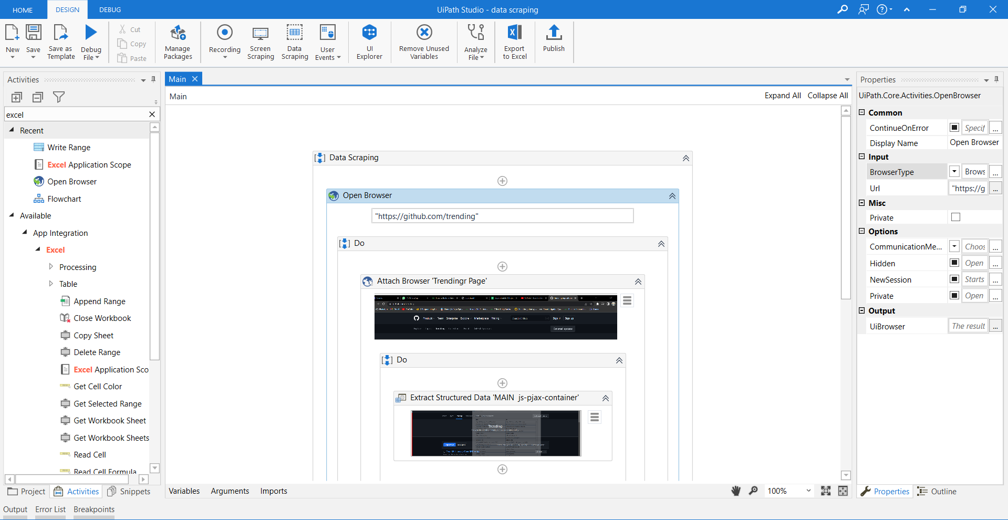

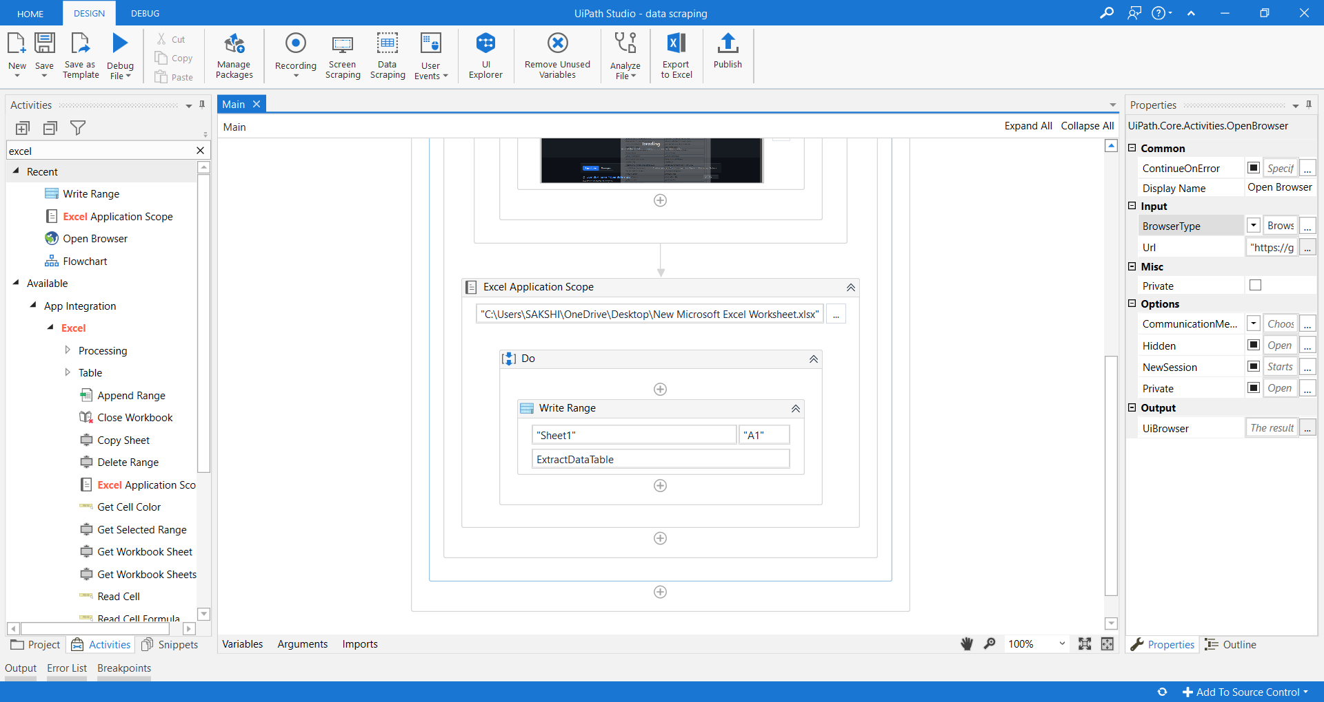

Screen shot of the uipath main screen

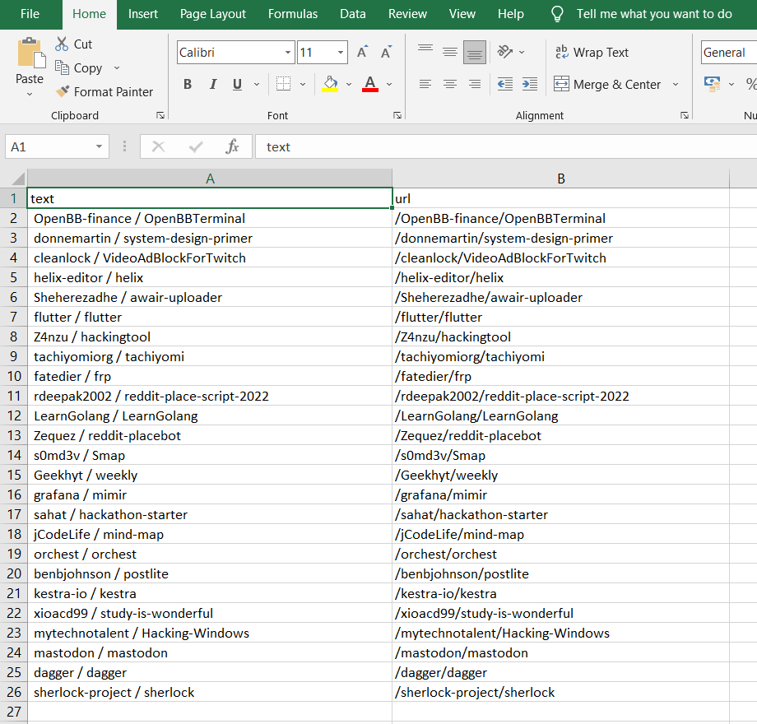

Screen shot of the excel sheet

The link for the output video:

"C:\Users\SAKSHI\Downloads\uipath project video.mp4"

